**COMP 4200 Final Project - Fitness Application**

**April 10th, 2023**

**Bryce Hughson**

**Tyler Johnston**

**Adam Taylor**

**Marina Zjalic**

# Table of Contents

**Table of Contents 2**

**Acknowledgements 3**

**Introduction 3**

**Objective 3**

**Project Requirements 3**

**Tools and Components 4**

**Project Development 5**

**User Manual 1****2**

**Conclusions 1****4**

**Limitations 1****4**

**Future Work 1****4**

**Github Link 1****5**

## 

## Acknowledgements

Our group would like to give thanks to our professor Shaon Bhatta Shuvo for all of the help and material provided throughout the semester. This has led to our group being able to collaborate together to produce a successful application.

## Introduction

Students throughout colleges and universities often participate in the world of fitness or recreational activities for various purposes whether it be for their physical health, mental health, or enjoyment of the hobby. Getting involved with working out requires research beforehand to educate the student with knowledge of the different kinds of workouts and what parts of the body they affect so they can develop a healthy and useful workout plan.

Our Fitness Application was designed with simplicity in mind and usability for students new to working out. A beginner friendly approach with simple demonstrations and displays of workouts that will get anyone new to working out off to the right start. Adding in the abilities to save specific workouts for later helps makes the newcomer all the more familiar and get working out sooner to reach their fitness goals.

## Objective

The objectives of this project were to create an application that was closely catered primarily to students but can also be used by the general public. Additionally, the group wanted to prioritize features and design that would make the application user and beginner friendly. A simplistic design and execution of app use was important to us as well since the primary focus was introducing and saving workouts for people new to working out.

## Project Requirements

**Functional Requirements:**

* A login and signup which leads the user to the main home page.
* Connectivity with a database so users can have their own preferences and profile.
* An activity that changes video and description based on the workout selected.
* Ability to track workout history
* Ability to track the users favorite workouts

## Tools and Components

To develop the project and other components our group used:

* Android Studio
* Github
* Java
* PowerPoint (Used to develop presentation)
* Word (Used to develop report)

Throughout the project our group used various components to allow for the functionality and visual aspects of the application:

**Layouts Used:**

* Constraint Layout
* Relative Layout
* Drawer Layout

**Views Used:**

* Card View
* Recycler View
* Text View
* Edit Text View
* List View

**Others:**

* Checkbox
* Video
* Switch

## 

## Project Development

**Creating the History Activity:**

1. To create the History Tracker page, I created a layout containing a TextView for the title, a button for adding a new record, and a ListView that will display all past workout history:

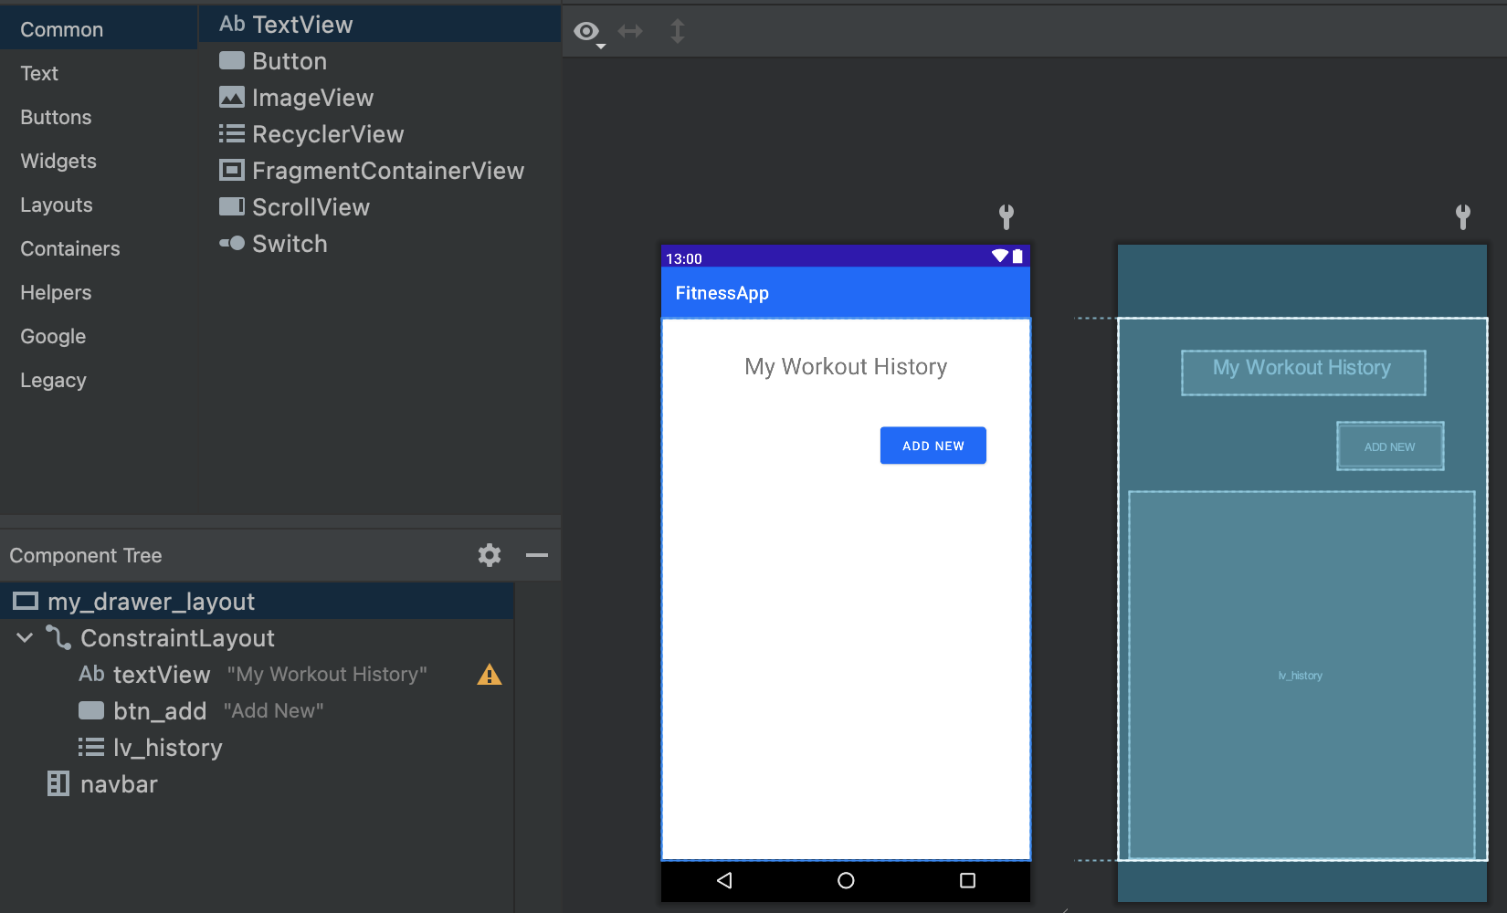

1. Next I created two additional methods in the DBHelper class for displaying and deleting records:



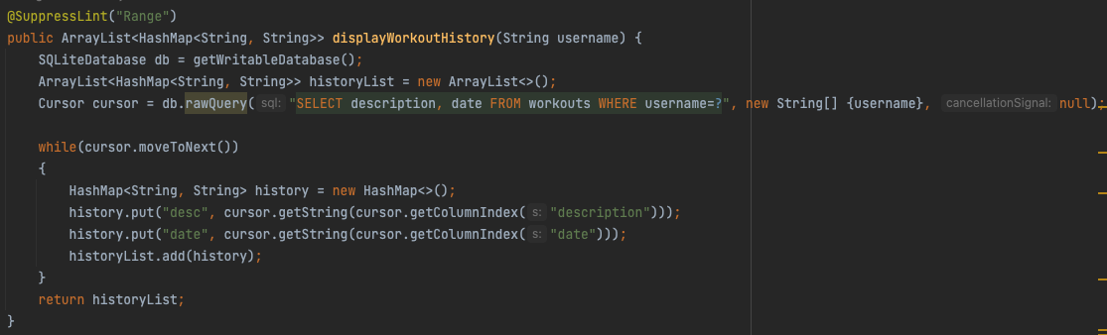

## 



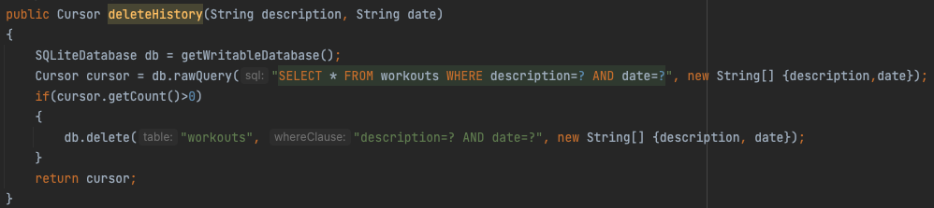

3) The next step was to add functionality to the History Tracker Activity:



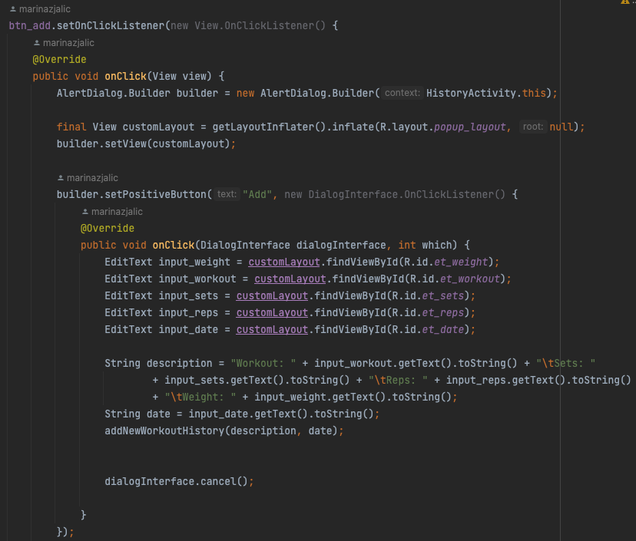

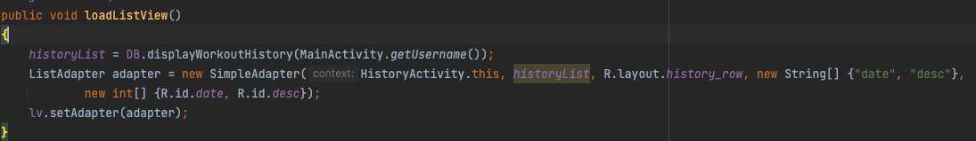

Adding a Menu Navigation Drawer:

1. The first step was creating the layout for the navigation menu as shown below:

Note: Every layout that will be using the navigation menu needs to have its contents wrapped in a DrawerLayout.

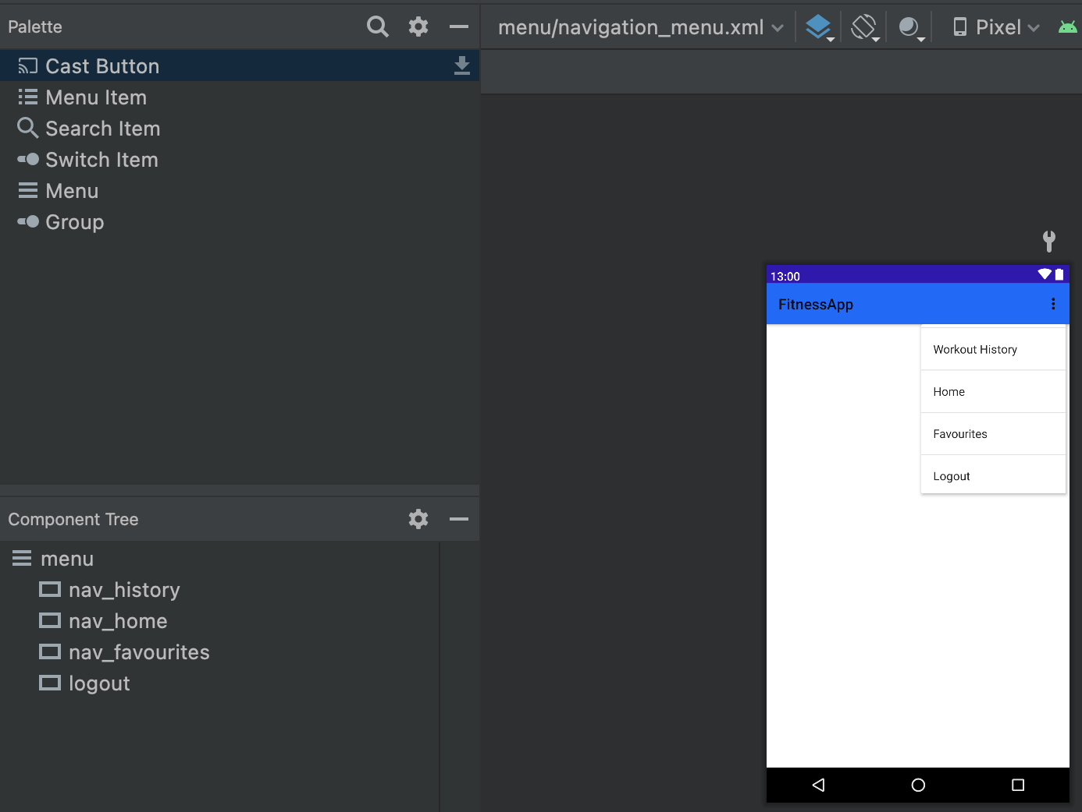

1. The following functionality was added to every layout that uses the menu navigation: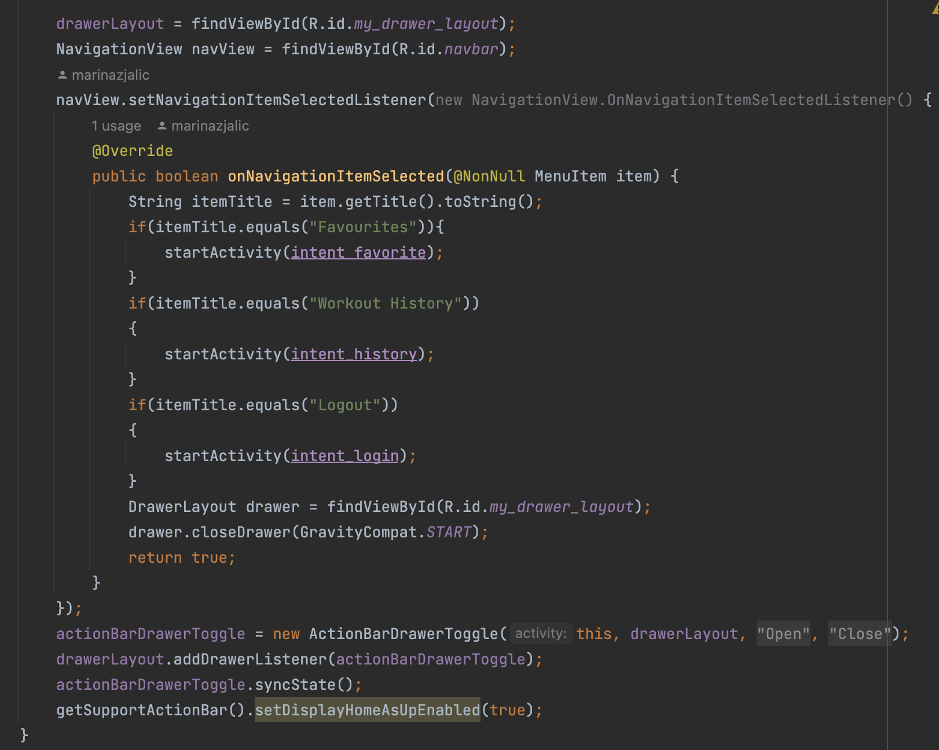



**Creating the Favorite Activity:**

1. The first step for creating this activity is much like any other. I used the cardview that was used for the home page in the application in order to display the workouts that the user selected to be favorited.
2. The functionality of the favorite button was then implemented to add the favorites to the database.
3. After that, it is as simple as pulling the information from the favorites list and adding them to the view with a loop of the list.size().

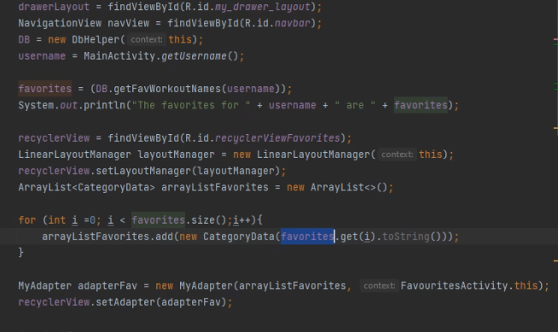

**Creating the Login Activity:**

1. This function allows for the user to enter their username and password.
2. After accepting the username and passwords as strings they are passed to the DBHelper function that has an SQLite table that takes in the respective values. After this it compares the values against each other.
3. The user also has the option to create an account, if one is already created. 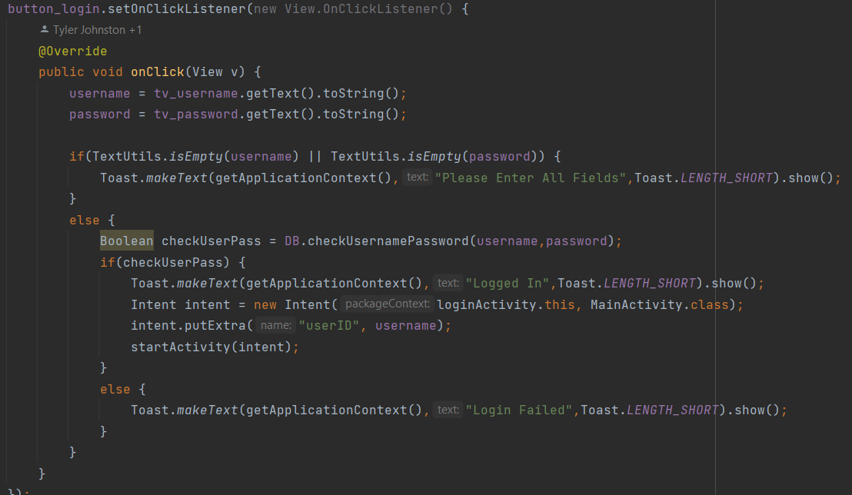

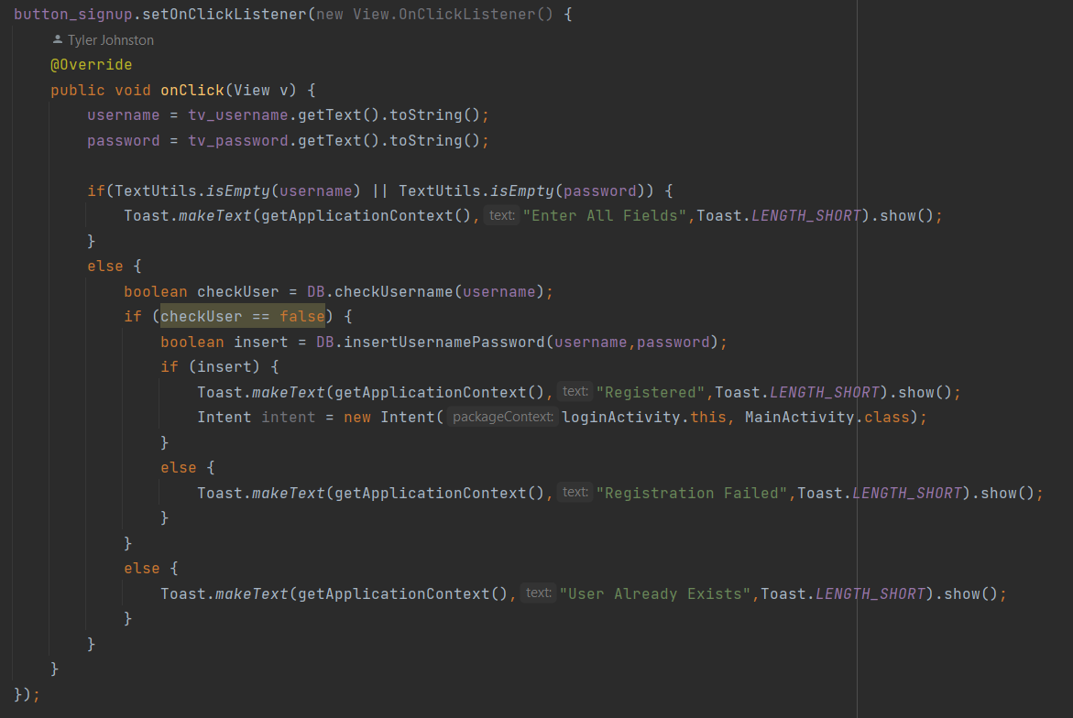

## 

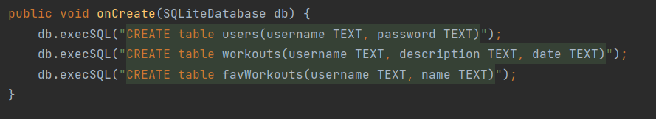

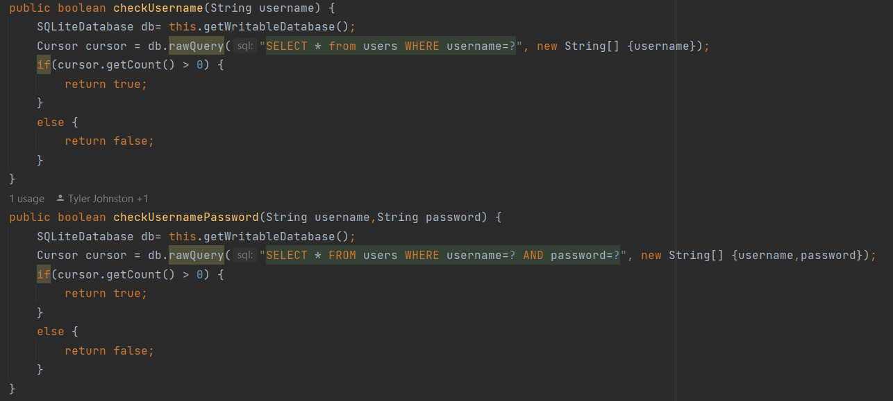

**Creating the Workout Activity:**

1. The first step is to create the activity and adding in a VideoView for the video, a textview for the description, a textview for the title and a checkbox for the favourite feature which is stylized with star style. 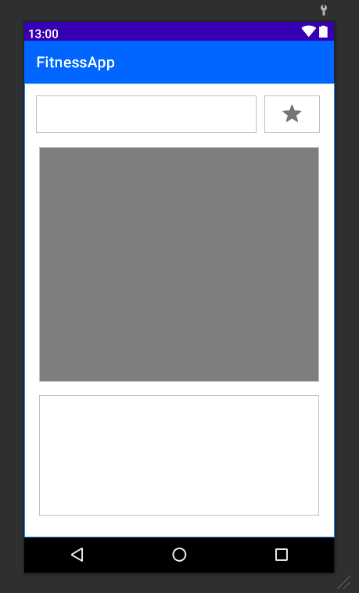

## 

1. Inside the adapter java class we have a switch statement that reads in what workout was selected from the previous activity. That sends over information to our workout activity such as “Title”, “Workout Video”, and “Description of workout”

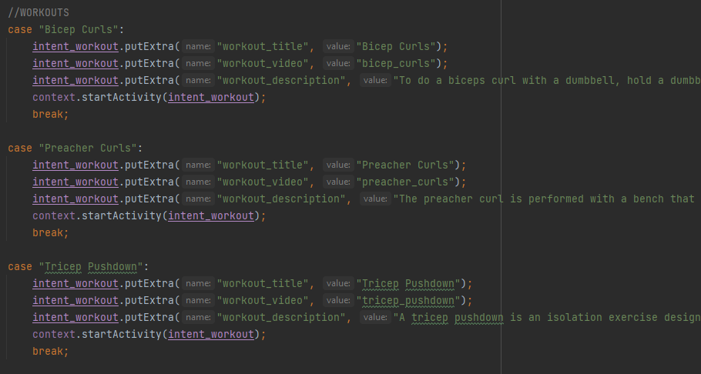

1. Lastly, inside the workout class we grab the information from the intents sent over from the previous activity and set the text and video url appropriately so the correct information is displayed to the user.

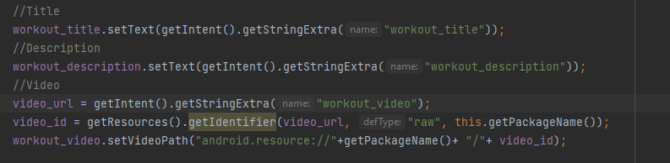

## 

## User Manual

## 





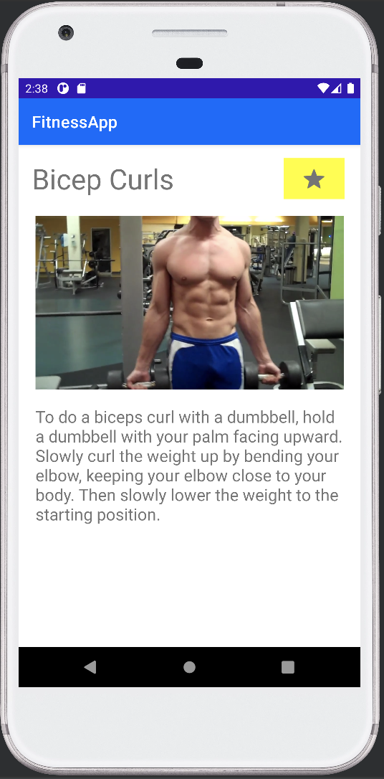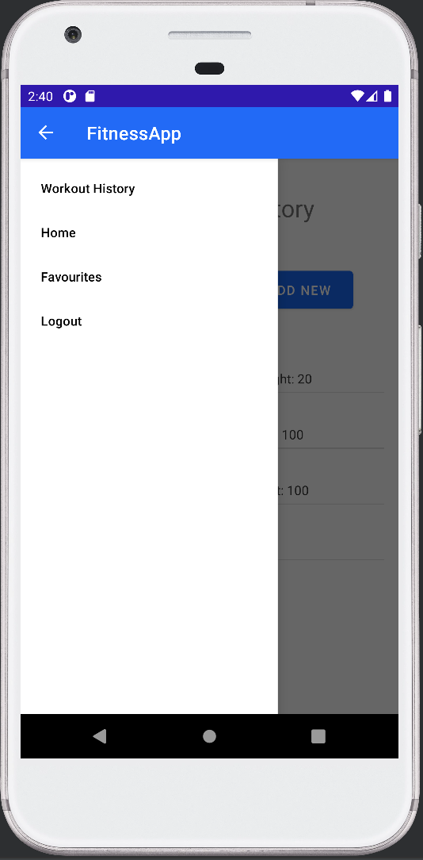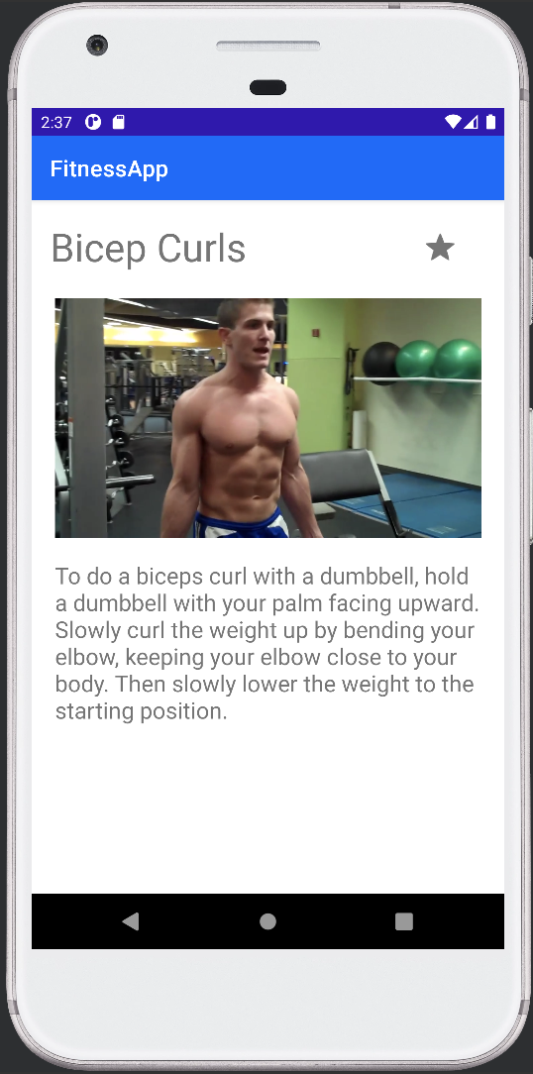





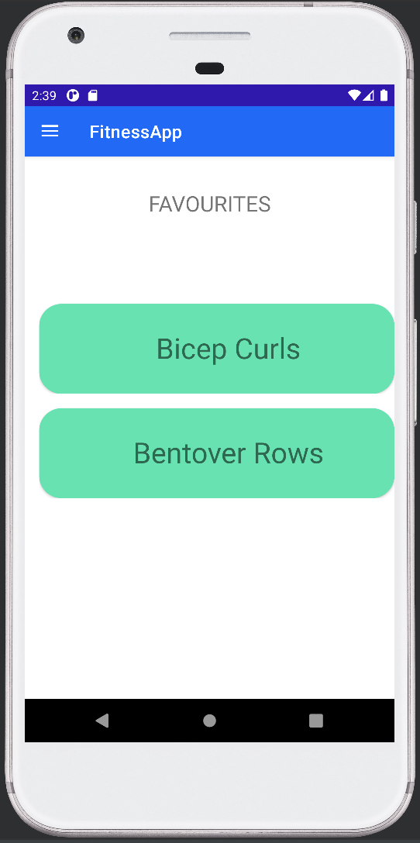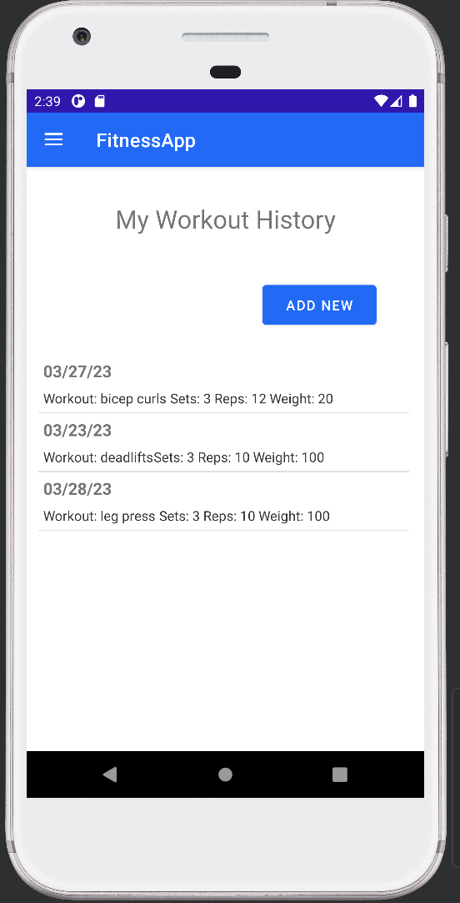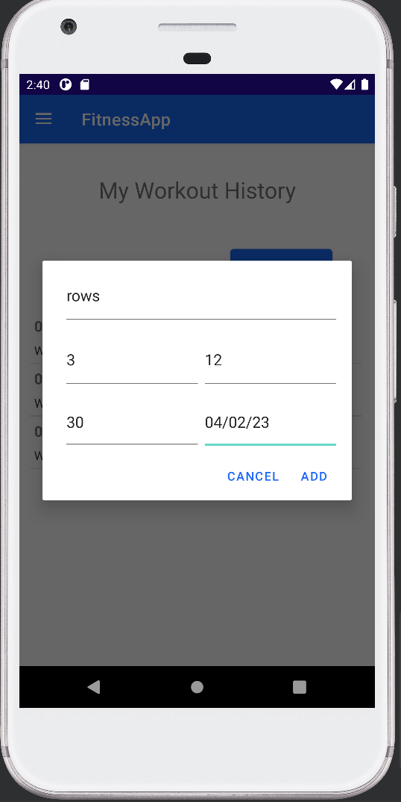



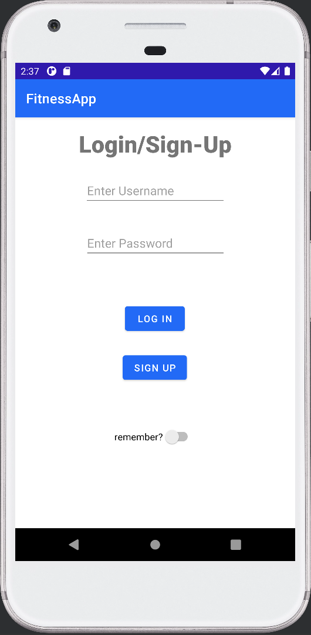

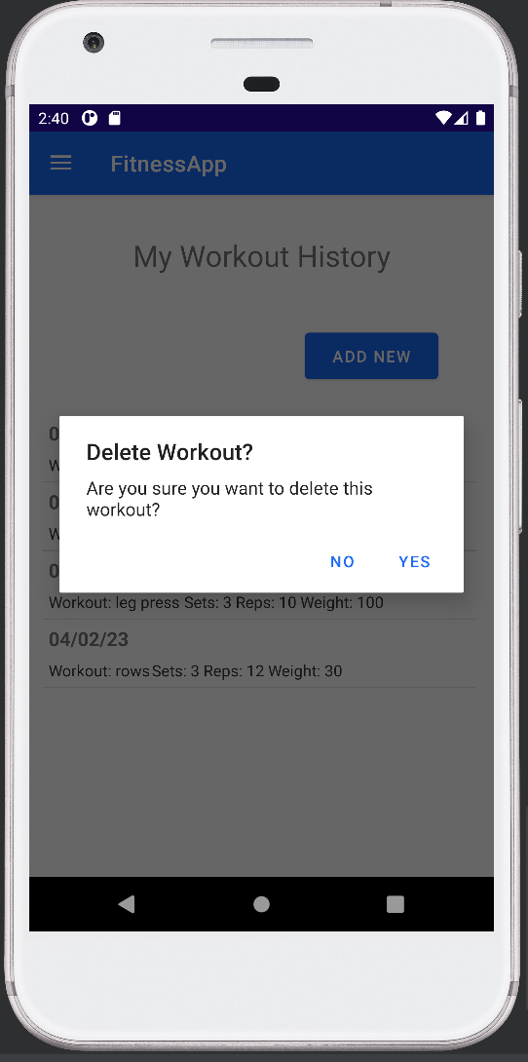



## Conclusions

In conclusion, the team was successful in developing and implementing the majority of features and requirements set out to do but as with all things, there were a few limitations both within the project and also timing constraint limitations. If time wasn’t a factor our next major goal would have been having a better design toward user interface by touching up the text and colours. Overall, the group had a finished product by the end of the deadline that was functional and we were content with that goal being achieved.

## Limitations

While our team was successfully able to apply the knowledge acquired in mobile application development in Android Studio, there were some limitations that affected our development process and overall success. These limitations include the following:

* + **Limited resources:** Due to limited resources, our database is currently stored locally as opposed to on a server.
  + **Time constraints:** Our team faced time constraints as we were subjected to meeting our project requirements and objectives on a tight deadline. Since we didn’t have much time to allocate to design and testing, some features that are lacking due to this constraint include the ability to unfavourite workouts and appealing user interfaces.
  + **Accessibility:** This application is currently only supported on Android mobile devices, and is incompatible with other popular mobile operating systems such as iOS. This limits our target audience as users without an Android device are not able to use our application.

## Future Work

Some future work that would significantly improve the overall user experience includes improving the user interface to be more relevant and professional. Our current interfaces are basic and lack a common theme, so adding more styling and consistency would make our application more appealing to users. Additionally, we would like to improve the usability and performance by implementing a server side database connection instead of storing the information locally. This would allow users to access their information anywhere and from multiple devices. Further, we would like to improve the way we manage workout related data and make adding new workouts more efficient. Currently, our application features a static datasource for the workouts and their corresponding description and video. We would like to implement a dynamic framework that allows administrators to easily add and edit workouts without having to change the source code. Some features that would need to be included with these changes include a different authentication for administrators with additional layouts that enable adding and editing workouts.

Additional features we would like to include in future versions include making the application more personal by providing a user profile which stores relevant user information such as weight, height, etc. Allowing users to add their own workouts to their account would also improve usability, as well as allowing users to create their own workout plans. By adding these additional features, we would increase our target audience from beginners to intermediates as there is more to offer. Once this future work has been concluded, the last step our group can take is to launch our application on the App Store.

## Github Link

https://github.com/Hedges07/AppDevelopment-FitnessTracker